A000-AM,C-Nicaragua-Rivas Department-Nicoya-Figue-Female-Polychrome Ceramic-900 CE

Case No. 14

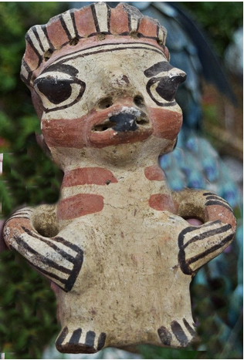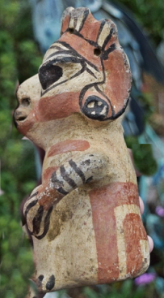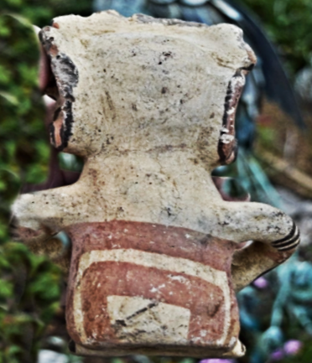

Nicoya female figurine from Rivas Department, Nicaragua.   
  
  
Rivas Department, Nicaragua, borders Lake Nicaragua to the east and the Pacific Ocean to the west. The southern part of the department borders with Costa Rica.

**Formal Label:**

**Accession Number:**

**Date or Time Horizon:**

**Geographical Area:** Rivas Department, Nicaragua

**Cultural Affiliation:** Nicoya

**Medium:** buff terracotta

**Dimensions:**

**Weight:**

**Provenance:** part of my collection found at an estate sale in Pasadena years ago professionally cleaned, no repairs or repainting, slight damage to crown from the estate of movie director Michael Cimino

**Condition:**

**Discussion:**

**References:**

